Lab Day-19 Numpy Stastical Function

1. How to find the mean of every NumPy array in the given list?

Input: list = [ np.array([3, 2, 8, 9]), np.array([4, 12, 34, 25, 78]), np.array([23, 12, 67]) ]

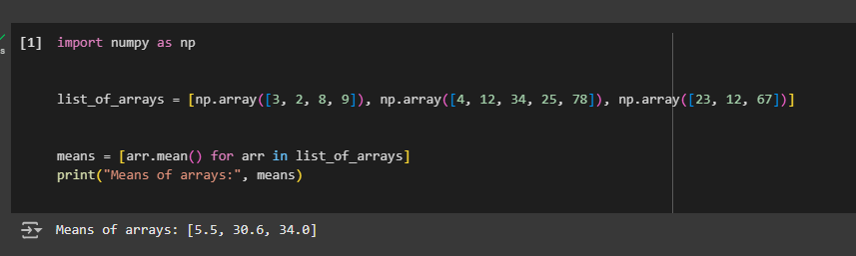

2. Compute the median of the flattened NumPy array.

Input: x_odd = np.array([1, 2, 3, 4, 5, 6, 7])

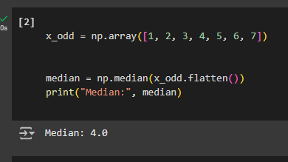

3.Compute the standard deviation of the NumPy array.

Input: arr = [20, 2, 7, 1, 34]

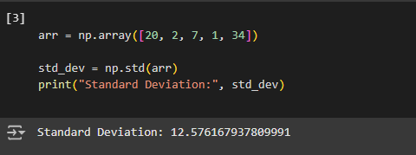

4.Suppose you have a CSV file named 'house_prices.csv' with price information, and you want to perform the following operations:

● 1.Read the data from the CSV file into a NumPy array.

● 2.Calculate the average of house prices.

● 3.Identify house price above the average.

● 4.Save the list of high prices to a new CSV file.

